

**Take That For Data!**

**How to React When The General Manager Wants to Talk**

*Project Abstract*

***Research Topic***

Ticket pricing for professional sporting events has undergone a seismic shift over the past decade as clubs have moved toward dynamic pricing practices. By analyzing ticket listings on sites such as StubHub, teams are able to gauge the market value of their product and adjust pricing to either take advantage of greater demand for high profile games or recognize lower valuations (but incremental revenue) for less marquee events. This pricing practice generally works because the past few years of secondary market activity can act as an excellent predictor of future demand when the team’s game-play performance is consistent.

However, teams are dynamic, and often change - a key player can come or go, a chance win or loss can lead to the playoffs (or lack thereof), and injuries sometimes flare up at a moments notice. In particular, developments on the player operations side of the business can drastically and quickly change the value of both single and season tickets in the eyes of fans. Cleveland lost LeBron James this season and will probably see a drop in demand for tickets as they drop out of contention for their fifth Finals bid in a row. Conversely, the Lakers signed LeBron, igniting one of the largest and wealthiest fan bases in the world. They can expect to see the value of their tickets rise dramatically from the prior year. This ticketing phenomenom is significant, and quantifiable.

Our project is designed to help teams plan their best response to franchise-altering events like player-trades, as well as smaller shifts in expected team performance. Using secondary and primary market data, we will estimate the risk of market value attrition or improvement in ticket prices, for each segment and section in teams’ arenas. Put simply, we want to help teams understand how the value of specific tickets will shift from these events, so teams can better identify and maintain “at-risk” season ticket holders (assuming that they did not renew before then) and competitively re-price single game tickets before the season begins.

***Hypotheses***

* We expect that both large and small market teams will exhibit significant changes to ticket demand from one season to another when the roster turns over, and certain parts of the arena (e.g. lower vs upper bowl) will react in different magnitudes to this roster change.
* We believe the data will show that some teams manage this roster change better than others, by proactively pricing their primary tickets in line with the market.
* We believe that proxies for expected performance such as preseason power rankings will be powerful drivers of secondary market prices before the game starts.

***Potential Applications***

* For teams who have lost significant players from the prior year and are expecting a large dip in performance, our analysis can help them understand how to adjust their pricing to maintain engagement with their fans and minimize the fall in revenue. It can also alert teams to others who have managed this process well, and identify best practices in retention initiatives.
* For teams who expect to improve significantly, our analysis can provide a roadmap to increase revenue by capturing more of the expected increase in fan's willingness to pay by raising prices, and by minimizing revenue diverted into the secondary ticket market.
* For teams looking at smaller shifts in team performance, we hope that our analysis will help them understand what kind of price increases the market can bear throughout their arena.

***Proposed Methodology***

* We will analyze shifts in secondary market value for tickets from season to season in conjunction with predictors of team performances (change in player win-shares, ESPN.com power rankings, social media sentiment, etc.)

**Methodology 1:**

**Step 1: $Y_{it}=βX+ε_{it}$**

regress ticket value on all the predictors associated with team performance and any other variable

$X$: matrix that contains predictors------game location, holiday , power ranking for each team, total salary for the team players, others

$Y:$ The total value for each game. Price*Sales

**Step2: $ε_{it} = α*target_dummy + δ_{it}$**

use the residuals from the first step and regress on our target dummy variables.

Target_dummy: the dummy variables indicate our list of significant players is in that game.

Summary :

Step 1 excludes all the effects that might influence the value for the tickets in a single game, step2 test our hypothesis about ‘the presence of significant players’ will influence the value for games.

* Methodology 2:

Regression Discontinuity:

$$Y=DX+Wδ_{1}+U$$

$$D=1\left[X≥c\right]$$

$$X =Wδ_{2}+V$$

Y: is the popularity index for each player: which is a combination of social media metrics and viewership for the player.

W: is the vector of all observable characteristics that might impact the popularity

D: is the binary treatment indicator

X: is the salary for our players

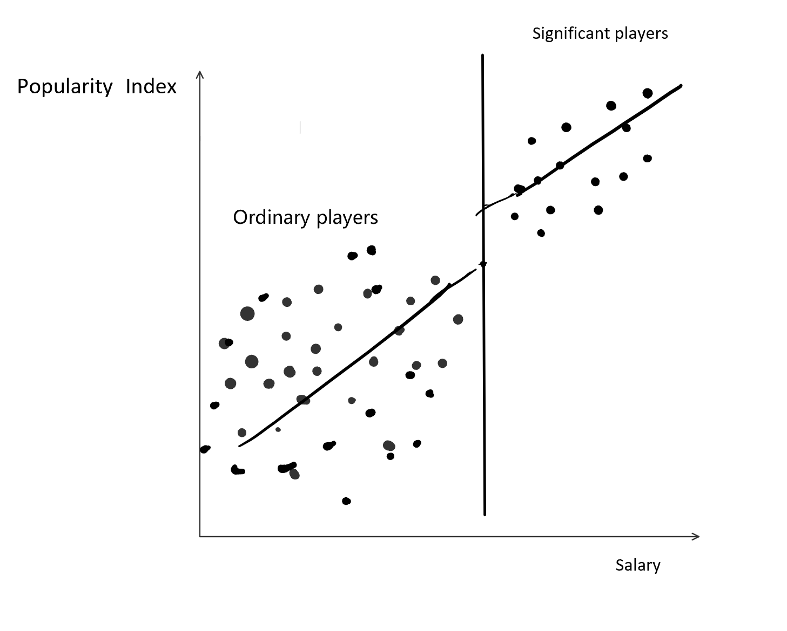

We would like to see on which threshold c would see a jump point for players popularity. This is useful to determine whether to hire or fire a basketball players.

* Once the analysis is complete, we will create a Tableau dashboard that teams can input an expected team record or power ranking into. The dashboard will then produce a map which predicts shifts in market value of tickets for different regions of the arena (e.g. upper/lower bowl, sideline/baseline/corner).

***Data Required***

* This is an ambitious, but doable project. Our ideal “wish list” would include (if available):
* Raw secondary market listing data for the past three to five seasons, ideally pulled before a season starts but after free agency (actual sale data would be great but we recognize this may not be possible)
* Primary ticket pricing for each team by price code
* Manifests (with maps if possible) that we can link these price codes to
* Anonymized season ticket holder data for each team, specifying tenure of membership. Ideally this would have identifiers that we could use to track members across different years to identify fans who drop out
* Beginning and ending team rosters over the past three to five years, ideally with measures of player value such as win shares included
* Data we can pull and expect to use includes:
* Google trend data around each team to track fan excitement
* StubHub API data for current year ticket listings
* ESPN.com power rankings